**Lab 2 – DIP – 20 September 2022**

**Task #1**: Reading and writing images with Python Imaging Library (PIL)

**Code**

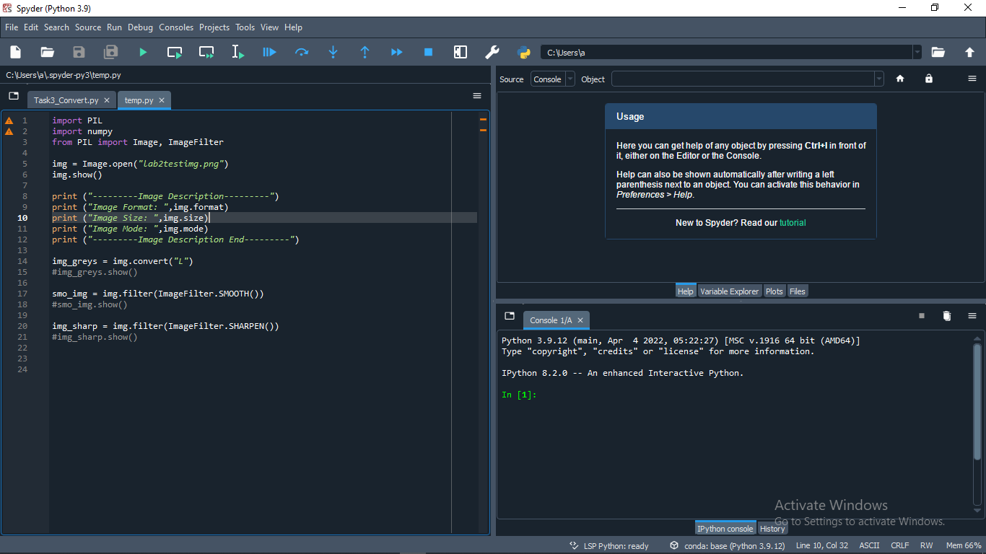

**Original**

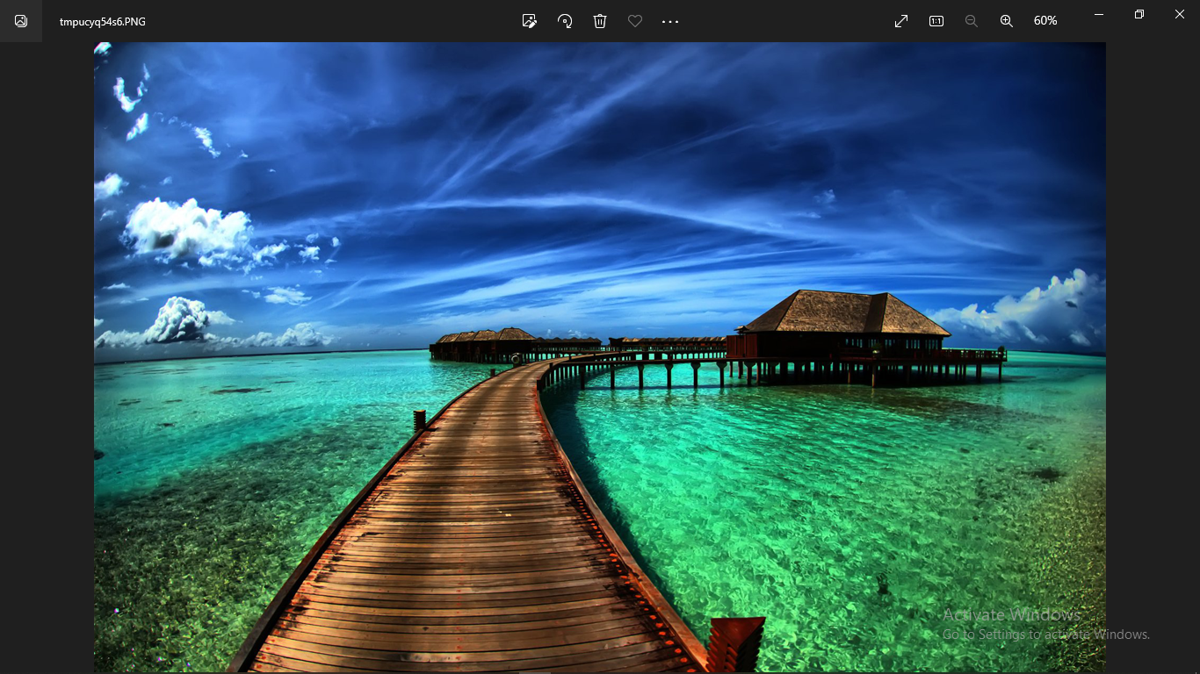

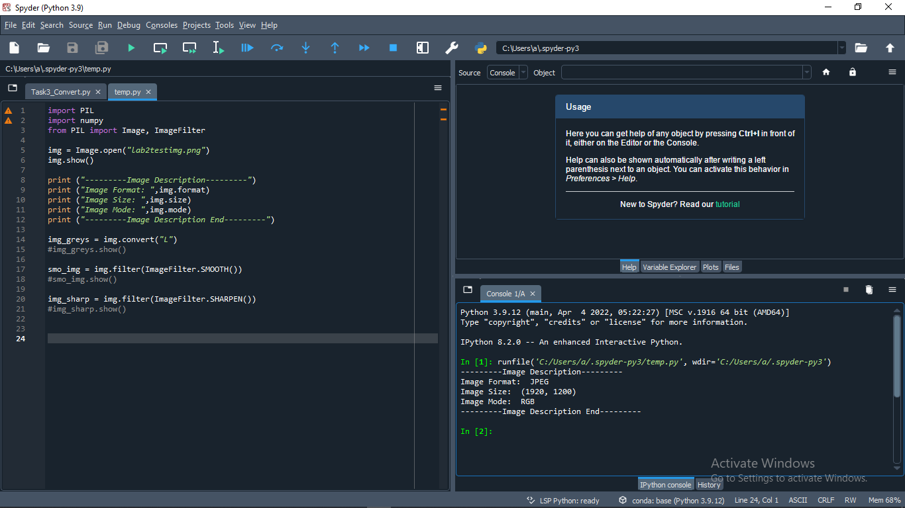

**Task 2**

**Convert files to JPEG**

A second argument can be supplied to the **save** method which explicitly specifies a file format.

**Code**

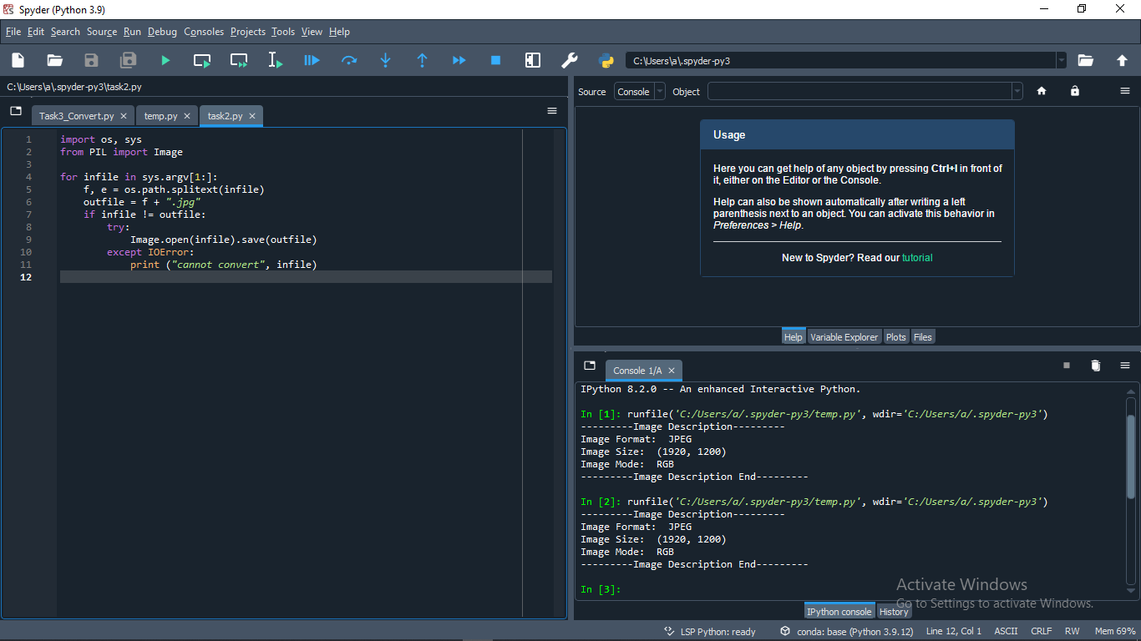

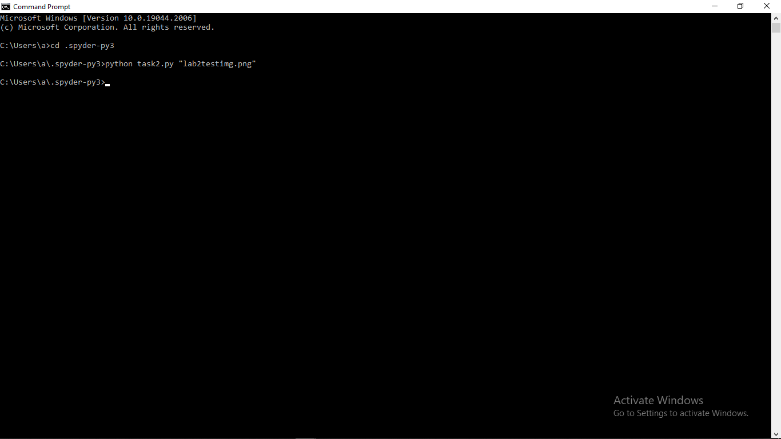

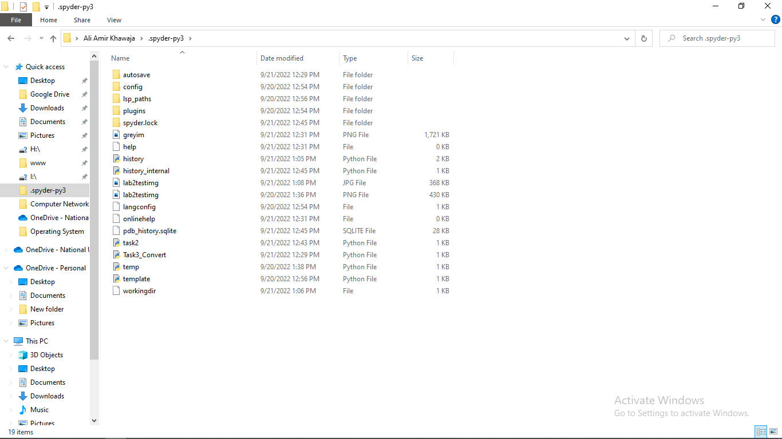

Lab2testimg.jpg Created

**Task #3: Play around with Python (PIL, numpy, etc.)**

1. **Convert RGB to Greyscale**

**Code**

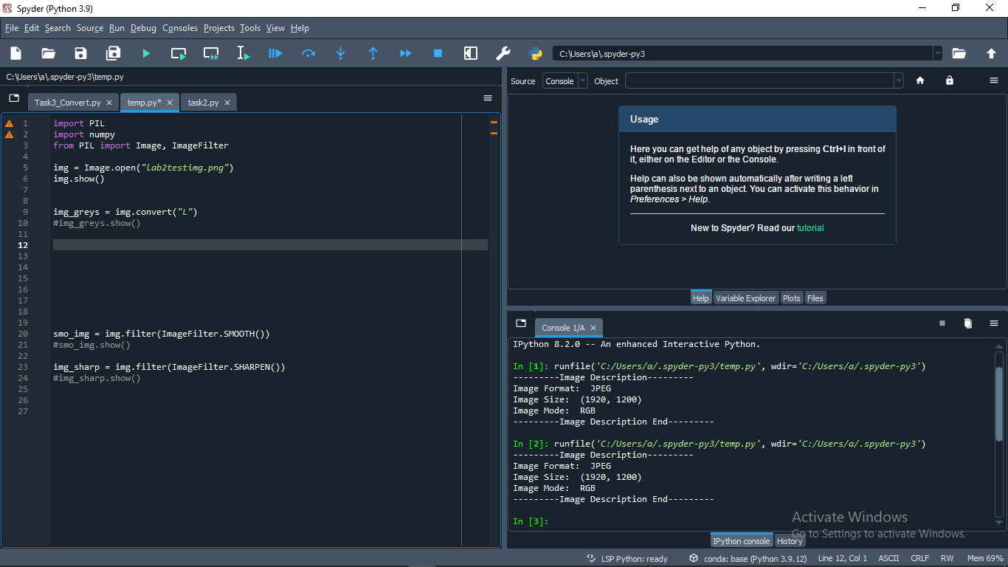

**Original**

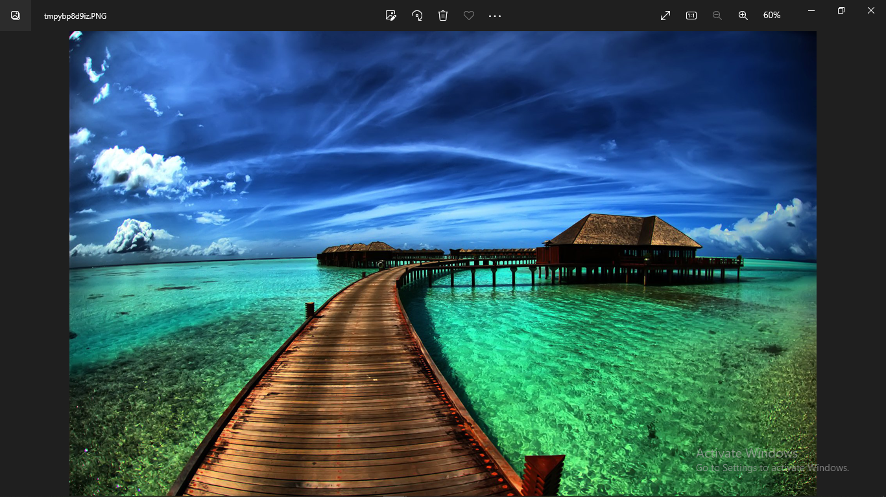

**Updated**

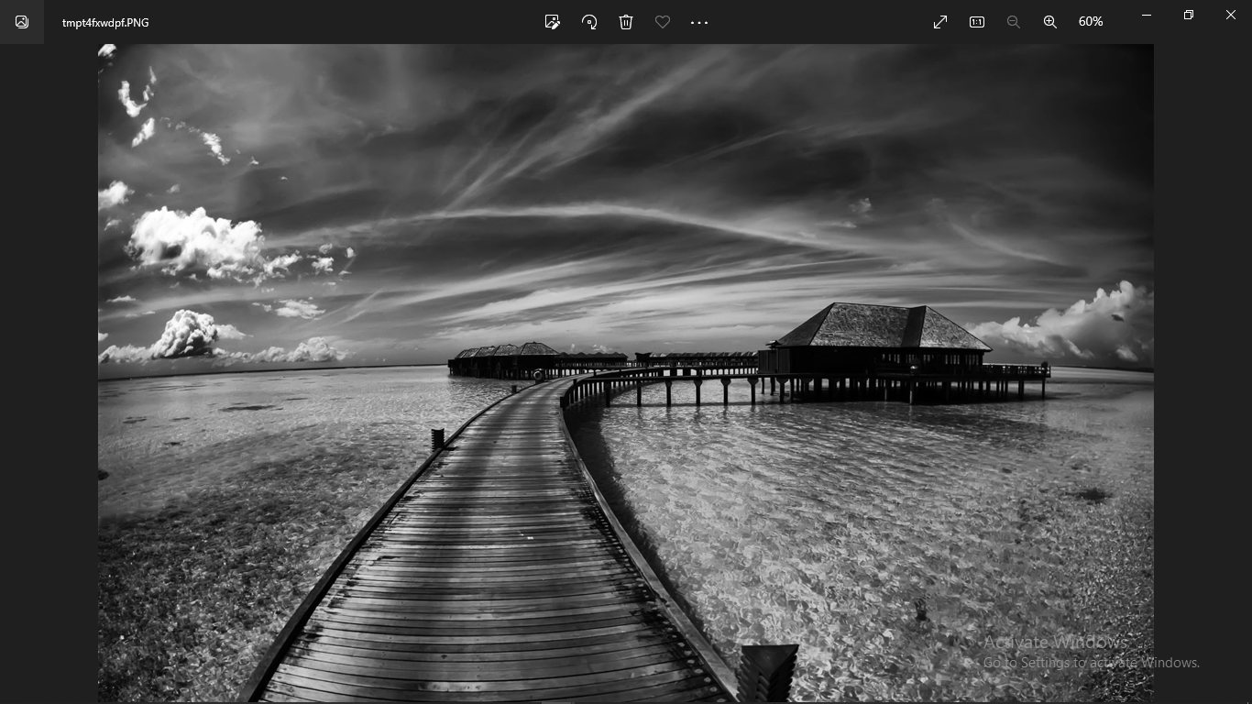

1. **Apply Smoothing filter (of your choice)**

**Code**

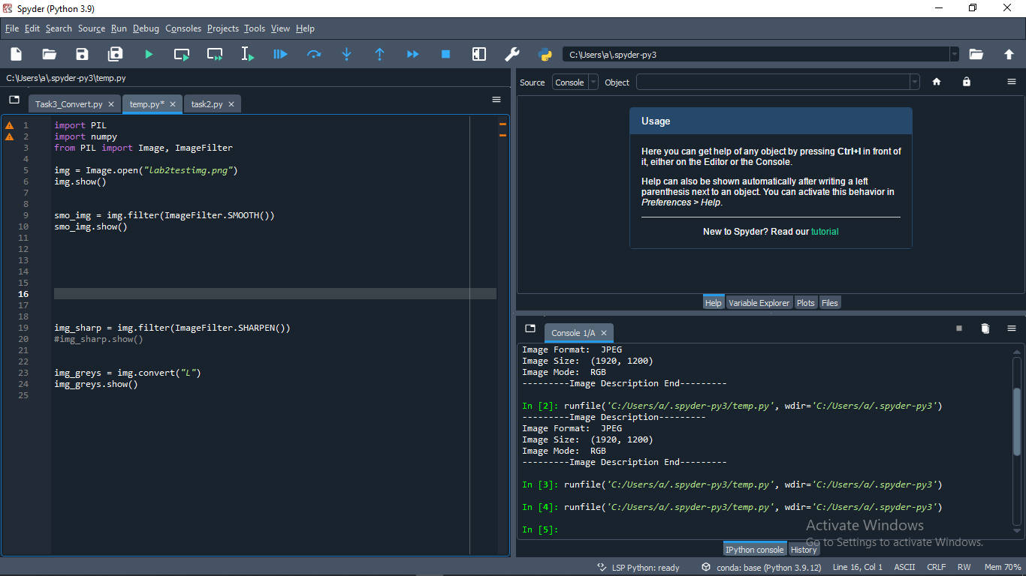

**Original**

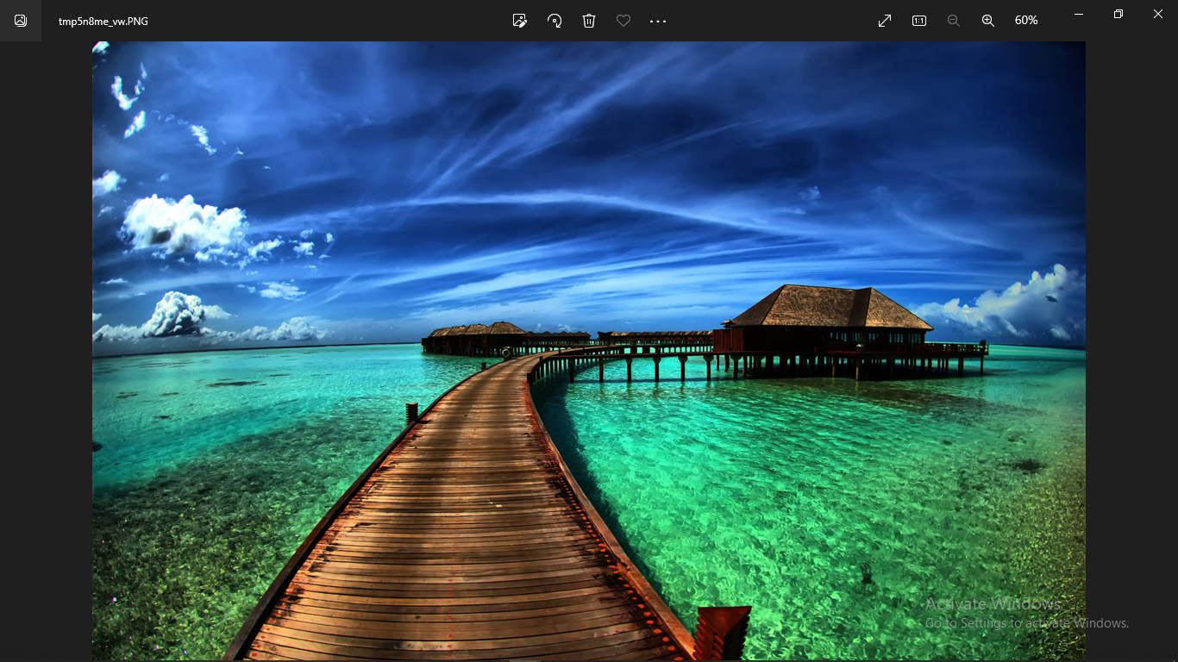

**Updated**

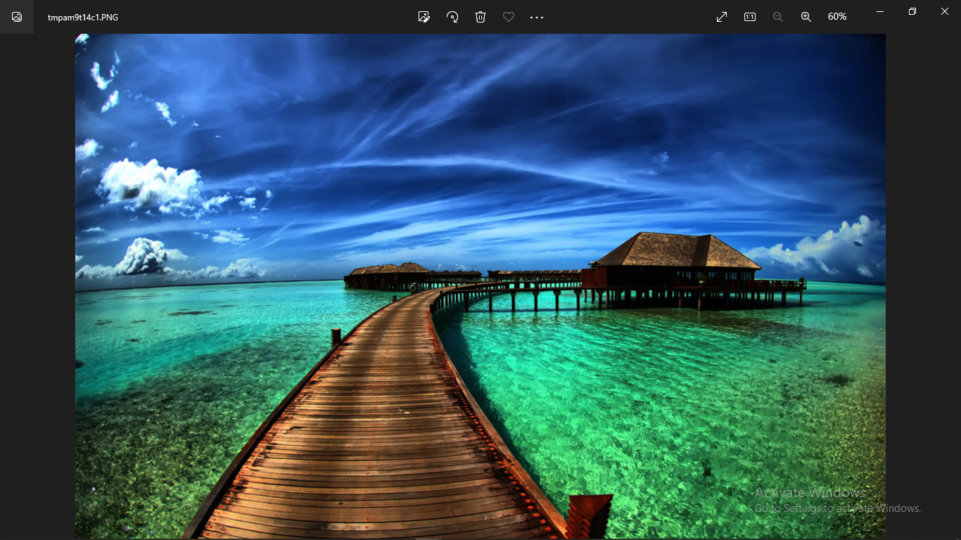

1. **Apply Sharpening filter (of your choice)**

**Code**

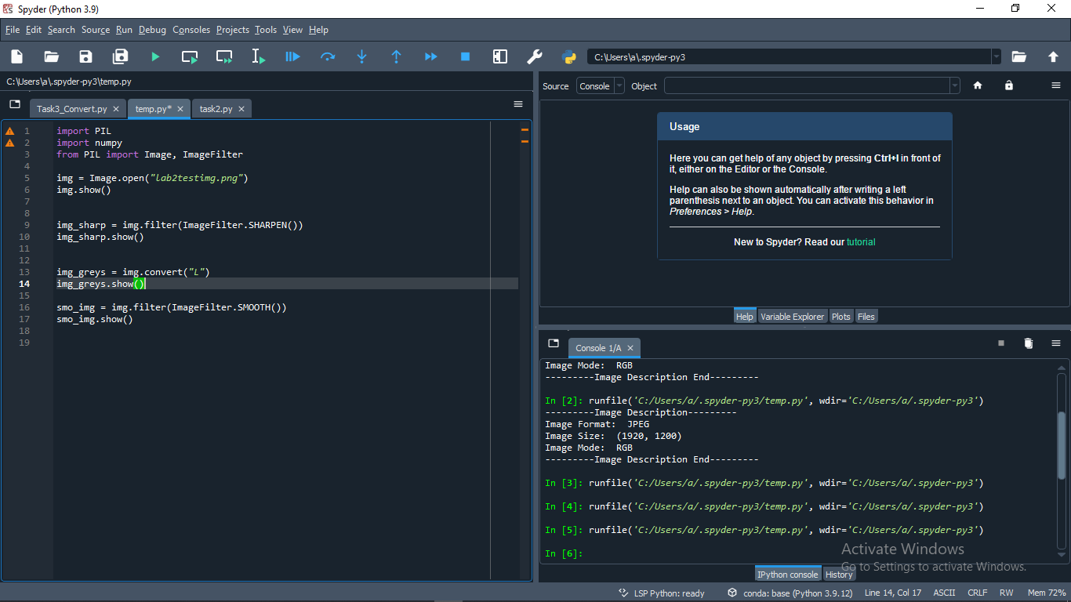

**Original**

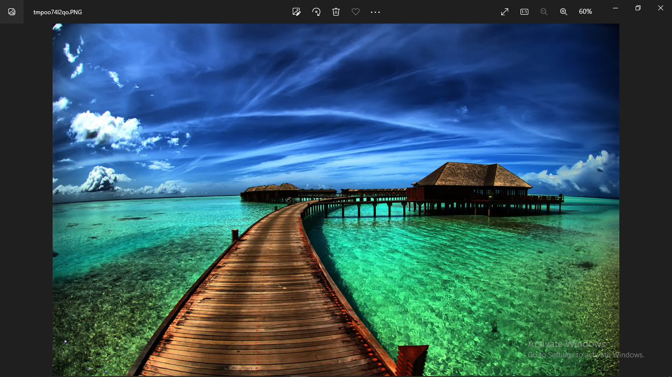

**Updated**

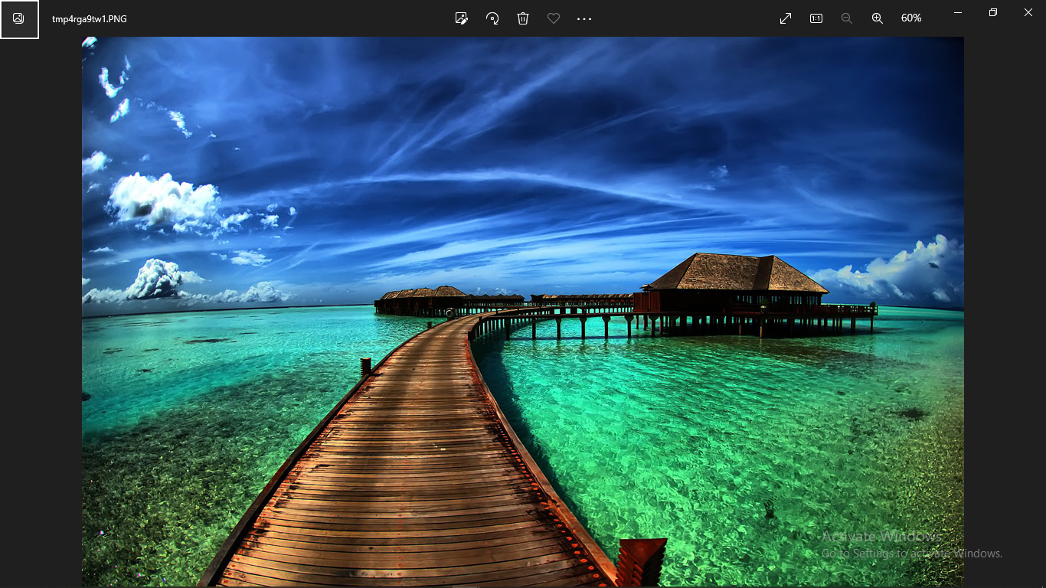

1. **Convert an RGB image to Greyscale (without using any Python package)**

**Code**

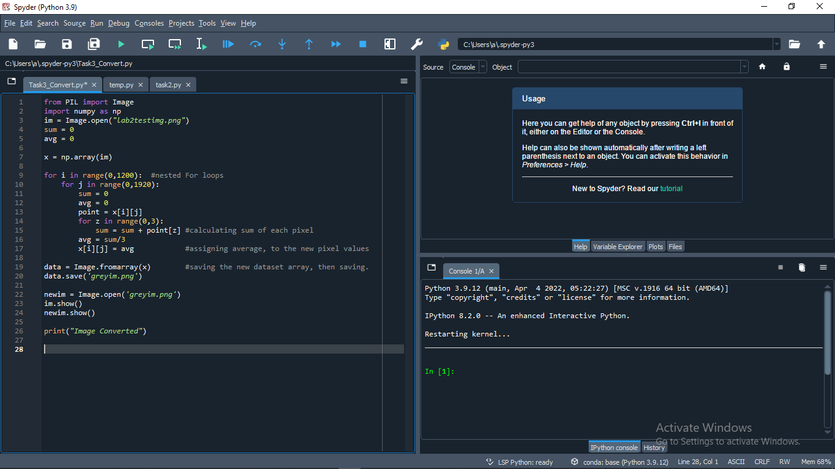

**Original**

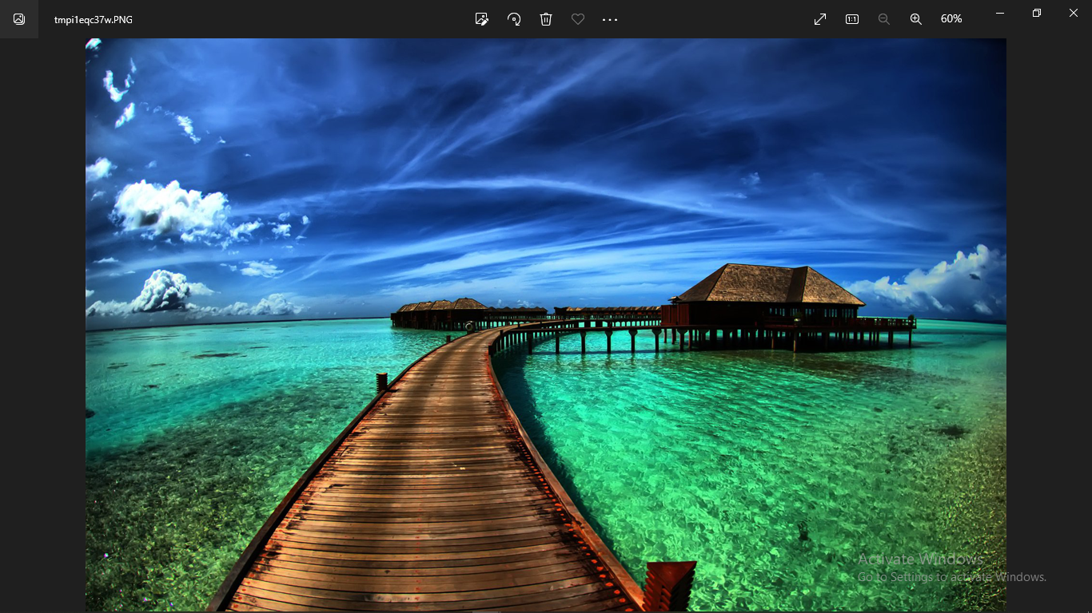

**Updated**

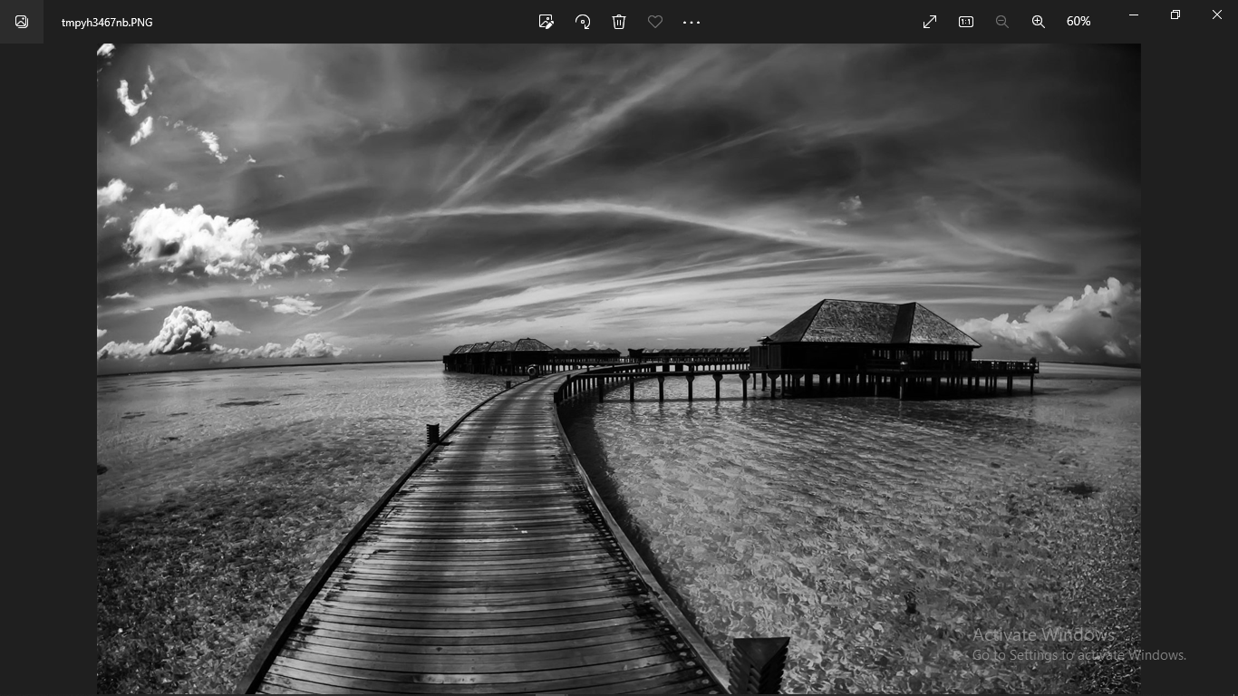

**Run Terminal**

